**User Interface:**

**a. Main Page (index.html):**

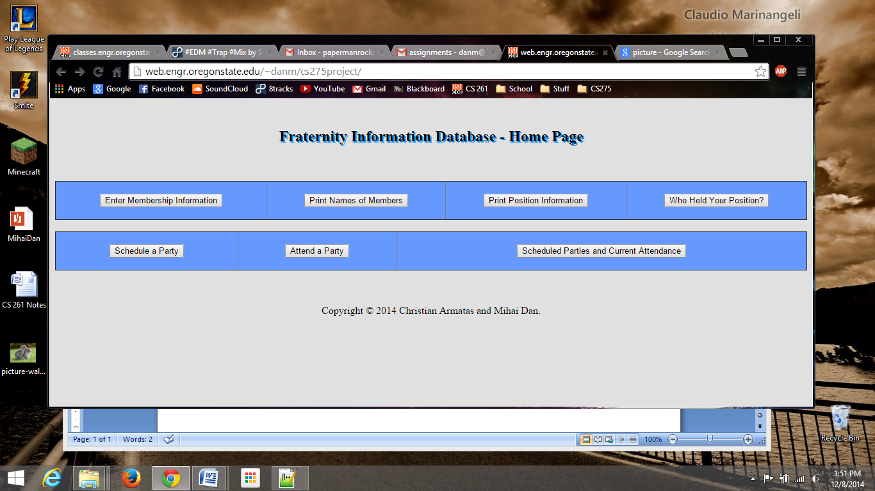

The main page serves an important part of the functionality of the website. It provides the user with the ability to navigate through the pages in an easy to follow menu.

**b. Enter Membership Information (enterMembershipInfo.php):**

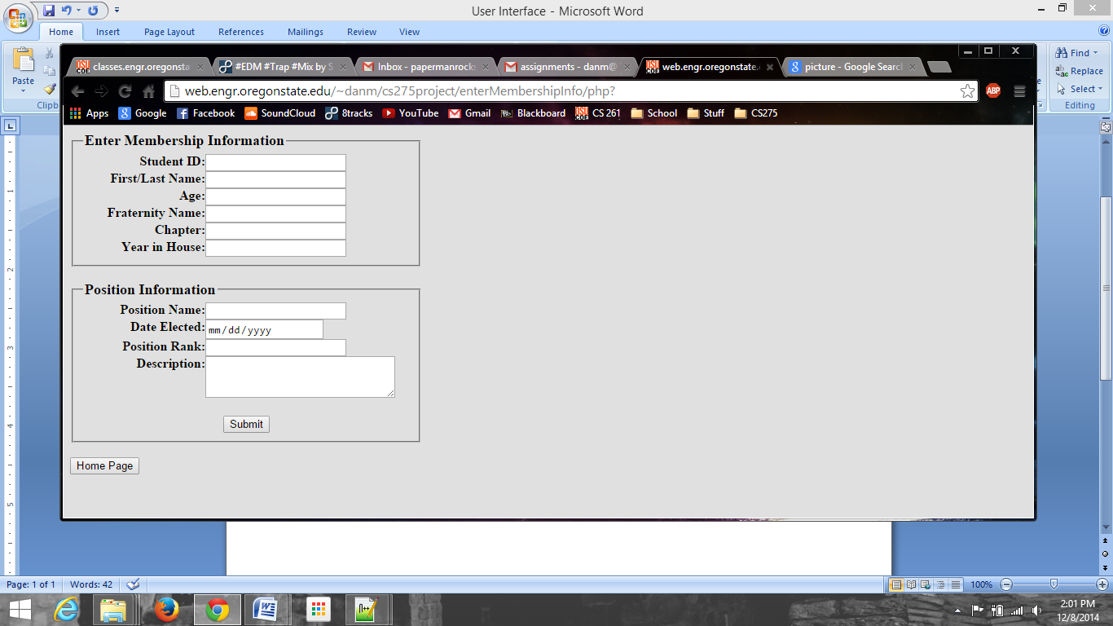

The Enter Membership Information page is the first page available in the menu. This webpage asks the user for personal information such as Student ID and age. Below, there is also an optional input box in case the member is holding a position in the house. This information gets submitted to the confirmation page shown part **c.**

**c. Member Info Confirmation (confirmInput.php):**

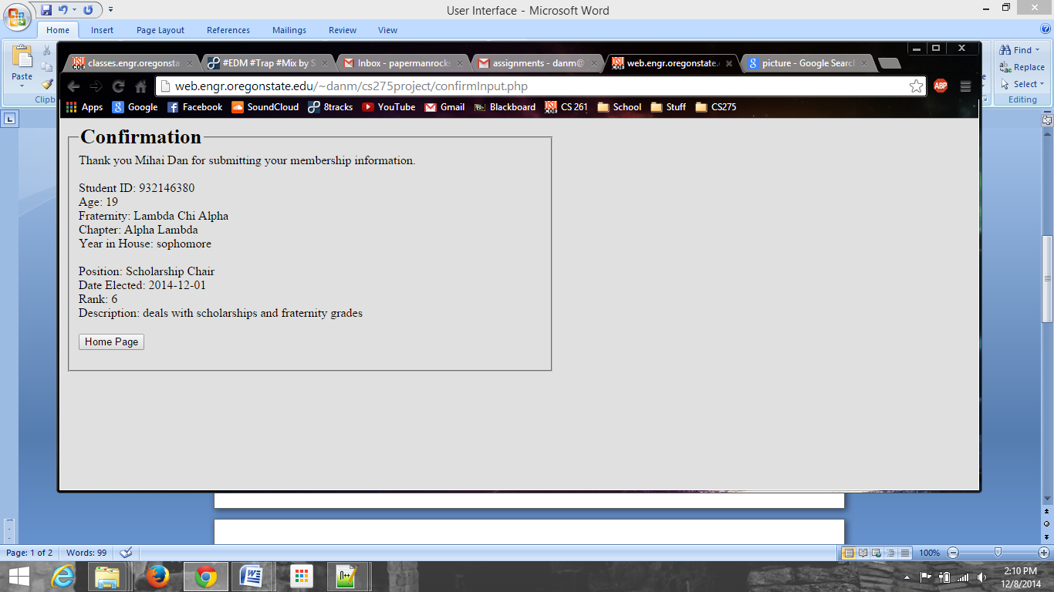

This page takes the information previously input into the Enter Membership Information webpage and displays it for the user to make sure everything was input correctly.

**d. List of Members (printMembers.php):**

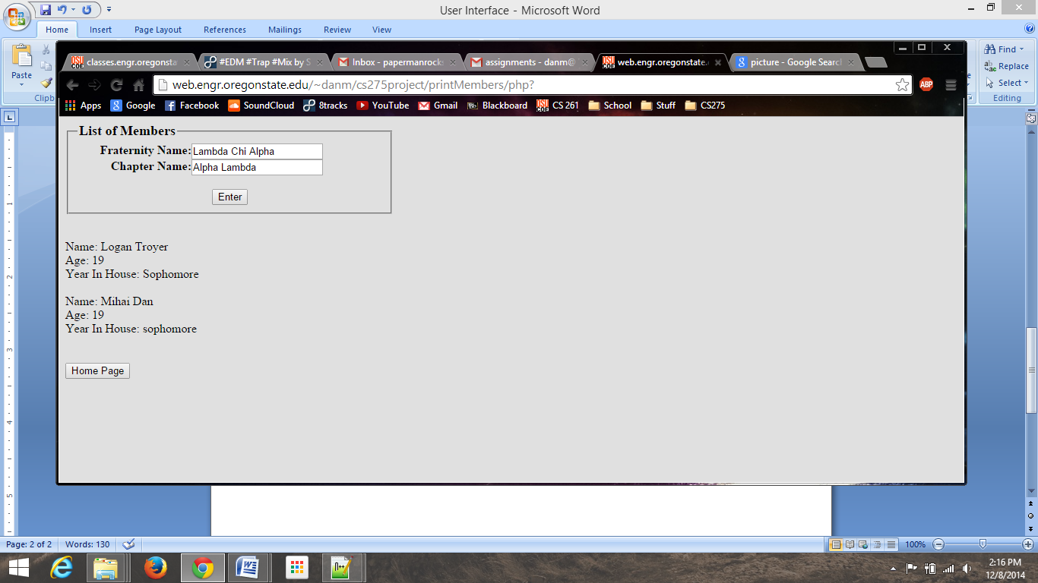

List of Members provides the user with an input box asking for their fraternity name and chapter. If there are members in the specified fraternity, their names, age, and year in the house will print out underneath the input box for easy accessibility.

User Input

**e. Print Position Information (printPositionInfo):**

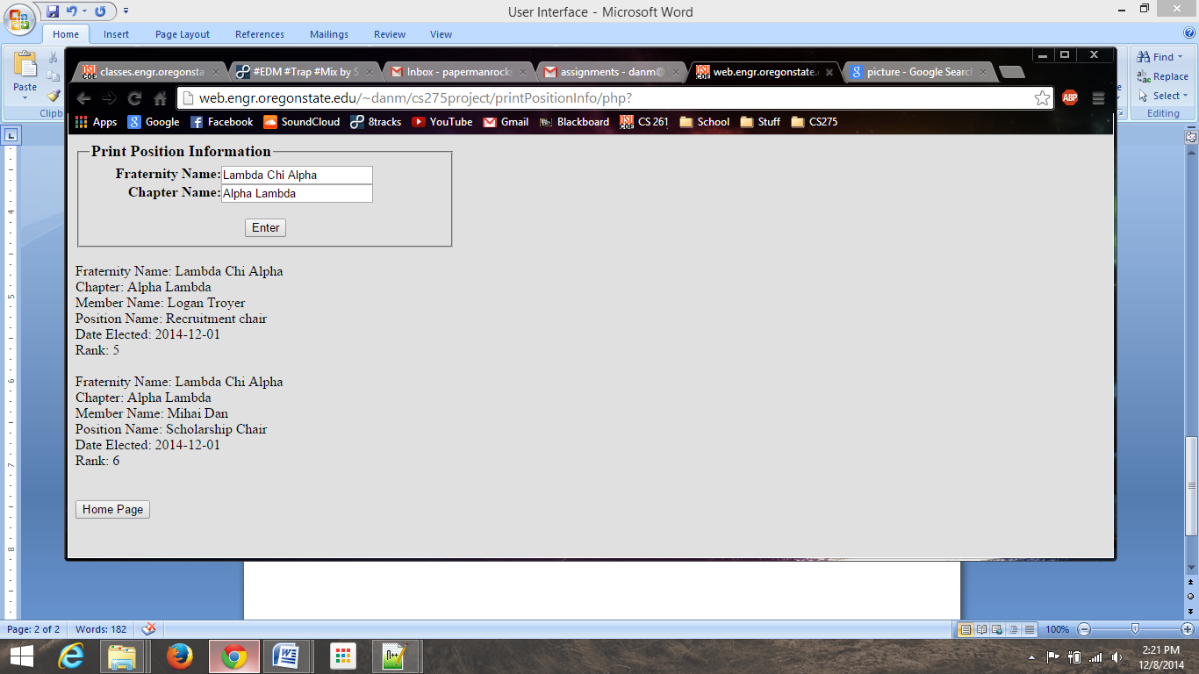

Much like the webpage described in section d., Print Position Information asks the user for their fraternity name and chapter, and displays information about the positions in the house, such as the member holding the position and the date elected.

User Input

**f. Who Held Your Position? (whoHeldPos.php):**

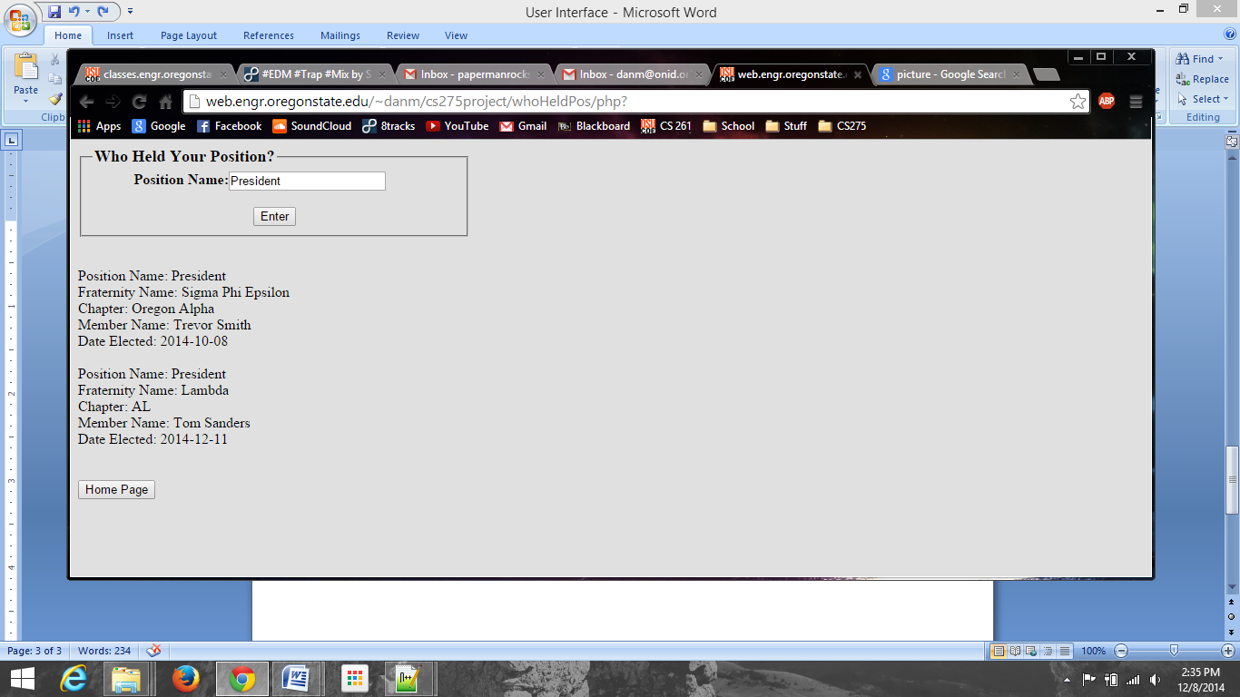

The Who Held Your Position? webpage allows the user to input their current position (or any position, for that matter) and see who held that certain position across multiple fraternities. This will also display old position holders and keep record of them as well as current position holders.

User Input

**g. Schedule a Party (enterPartyInfo.php):**

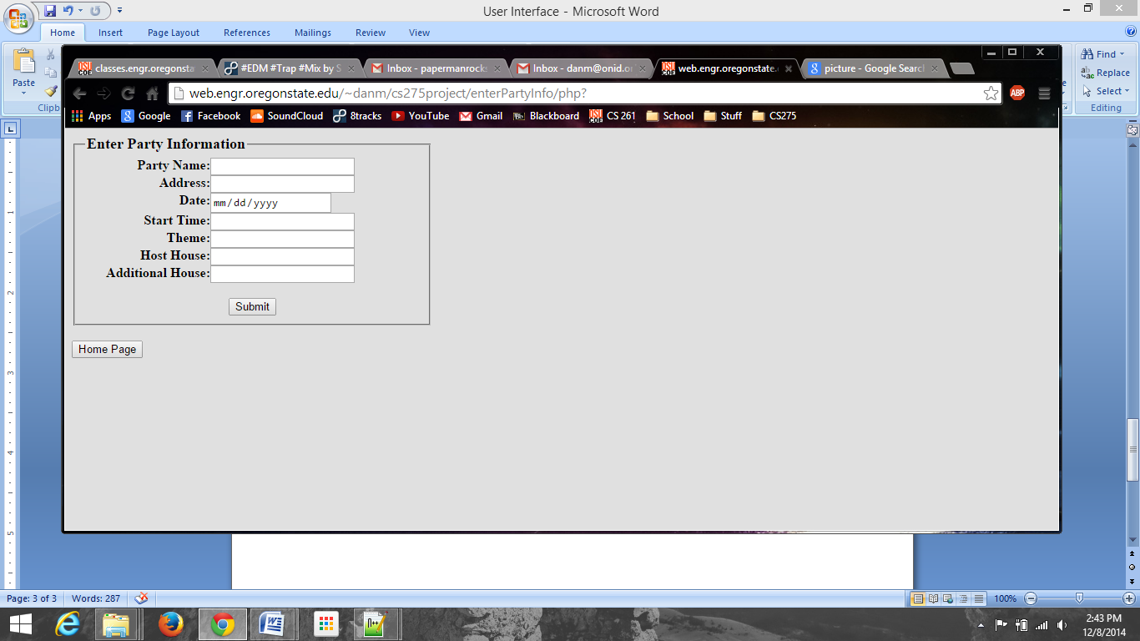

This webpage provides a place for members to input upcoming parties and information about them. This info varies from the party name to the host house. After being entered here, the information is displayed in the confirmation page shown in part **h.**

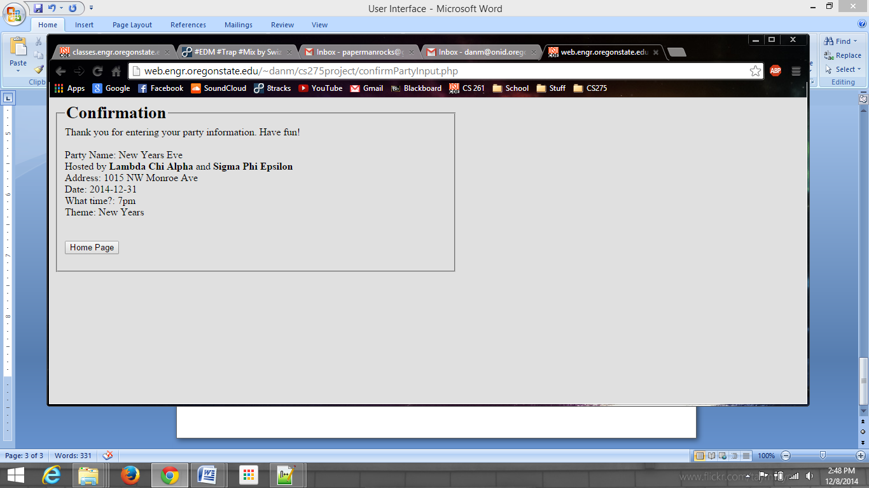**h. Party Confirmation (confirmPartyInput.php):**

This is the confirmation page to the Schedule a Party webpage specified in section **g.** This takes the information input by the user and formats it into a invitation style confirmation page.

**i. Enter Personal Information (enterAttendInfo.php):**

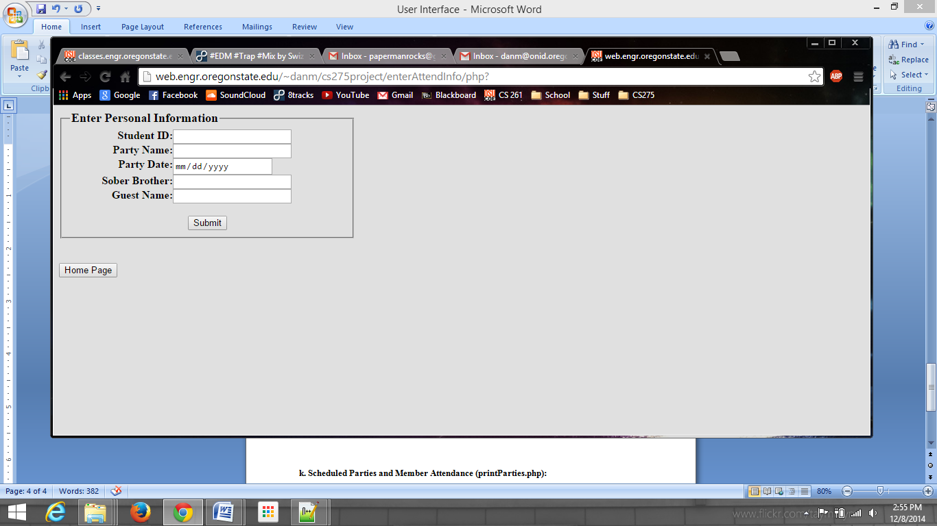

The input box on this page asks the user for their personal information regarding their attendance to a certain party or event. The information will be sent to the confirmation page in part **j.**

**j. Attendance Confirmation (confirmAttendInfo.php):**

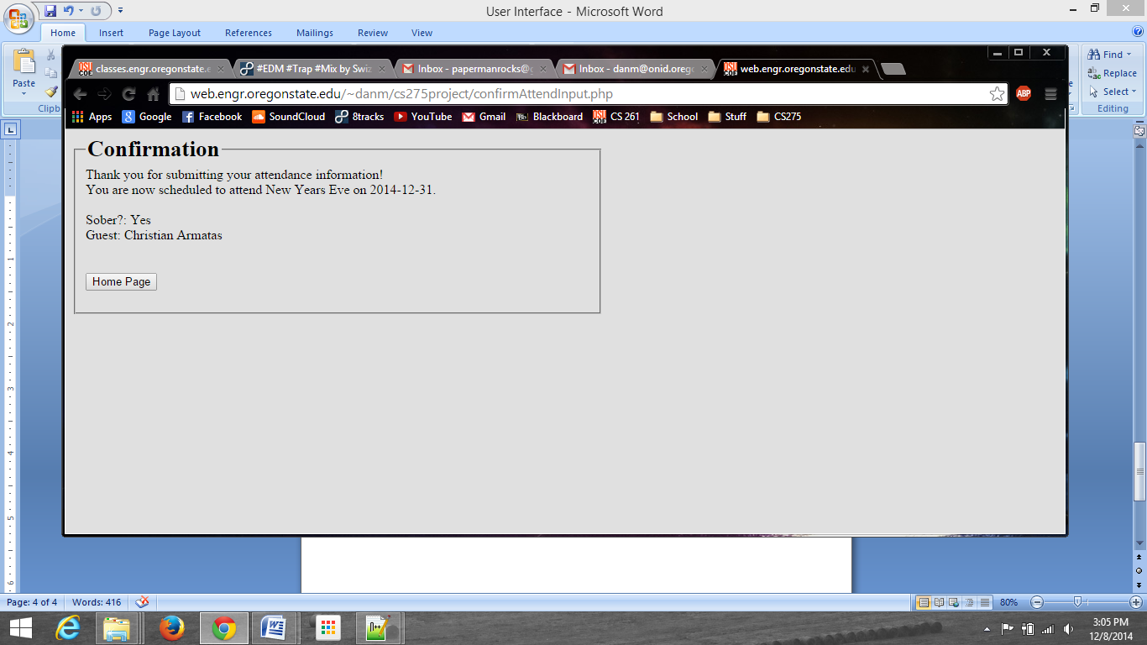

The confirmation page for the Enter Personal Information webpage shown in part **i.** takes the information submitted by the user and displays it on the screen in a very easy to follow description.

**k. Scheduled Parties and Member Attendance (printParties.php):**

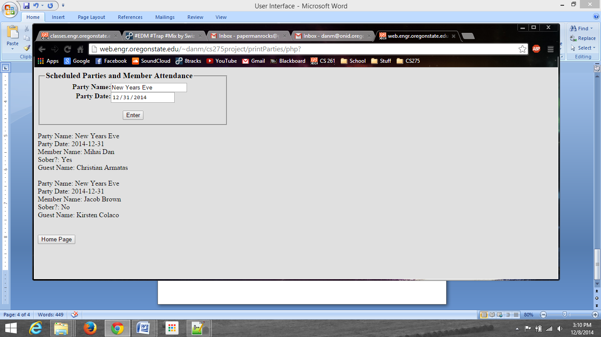

User Input

This webpage displays any events and members who attended each event based on the event (party) name and event (party) date. The names of members and guests will display as shown to the right.